

**ASSISTA AO VÍDEO “ ÁGUA “ .**

VAMOS CUIDADR DE NOSSAS ÁGUAS!

DEIXE SUA IMAGINAÇÃO FLUIR E DESENHE E PINTE UM RIO LIMPO E CHEIO DE PEIXES.

NOME:_______________________________________________________________

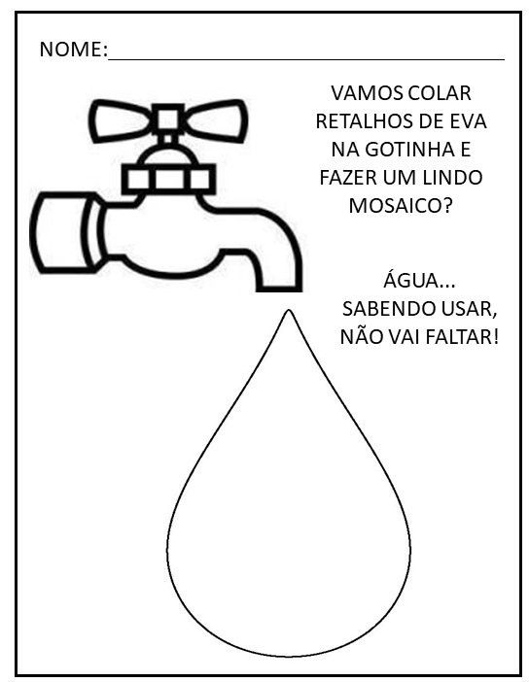

PINTE AS CENAS EM QUE HÁ DISPERDÍCIO E POLUIÇÃO DA ÁGUA:

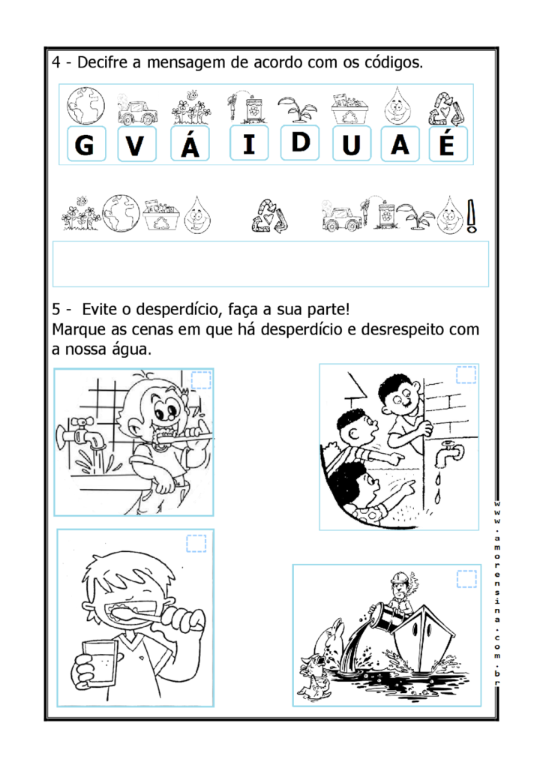

NOME:______________________________________________________________

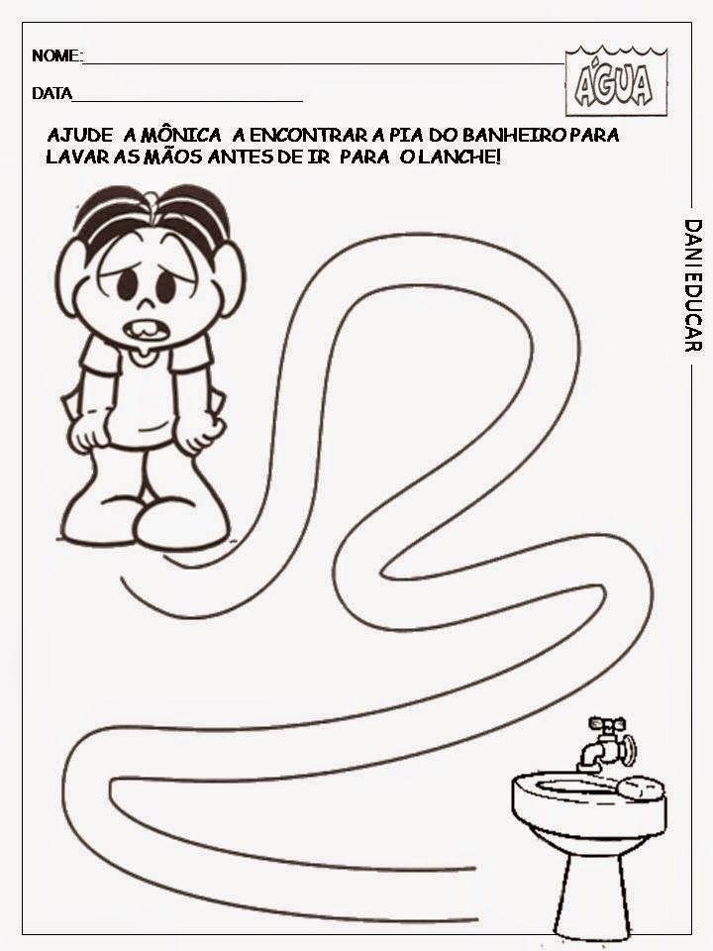

NOME:_______________________________________________________________

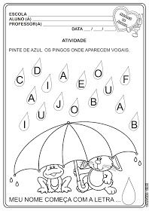

NOME:______________________________________________________________

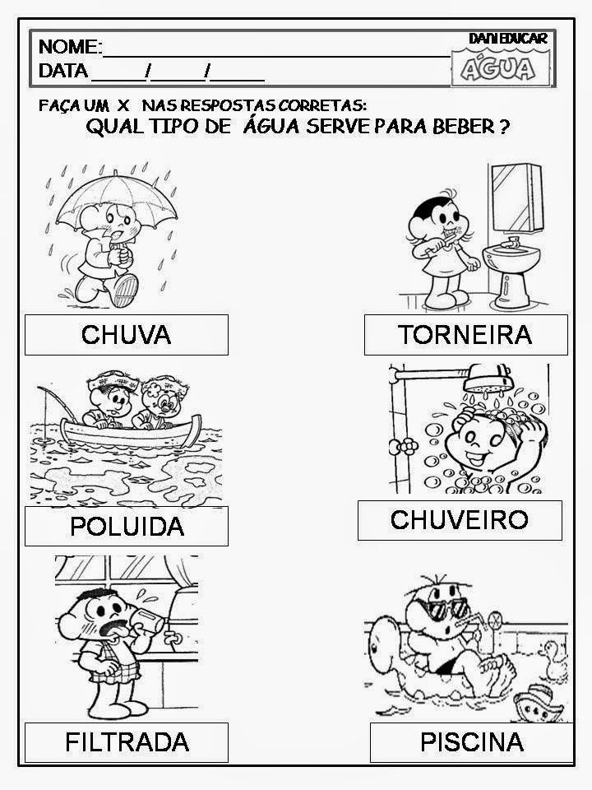

NOME:_______________________________________________________________

NOME:_______________________________________________________________

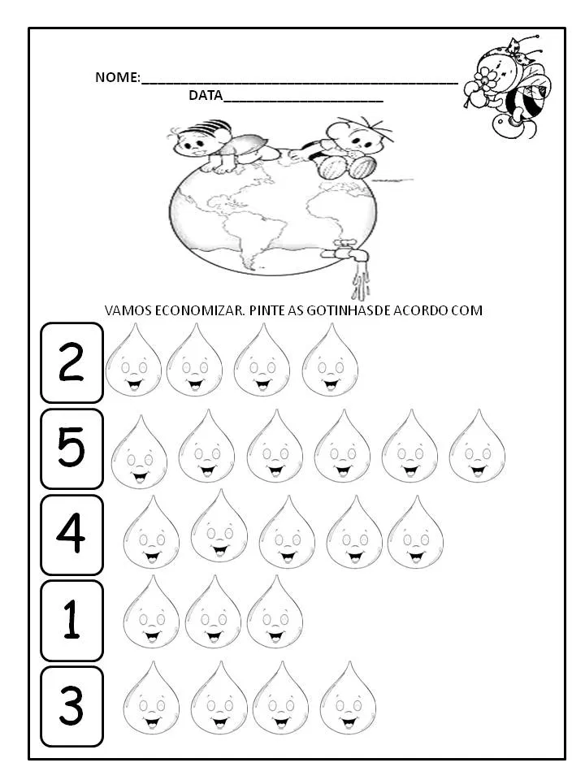

NOME:_____________________________________________________________

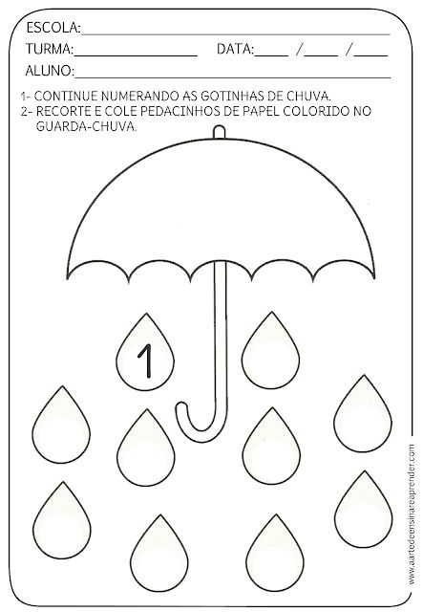

NOME:_______________________________________________________________