

ASSISTA AO VÍDEO DA HISTÓRIA “ DEZ SACIZINHOS”, QUE SERÁ ENVIADO NO GRUPO DE WHATSAPP.

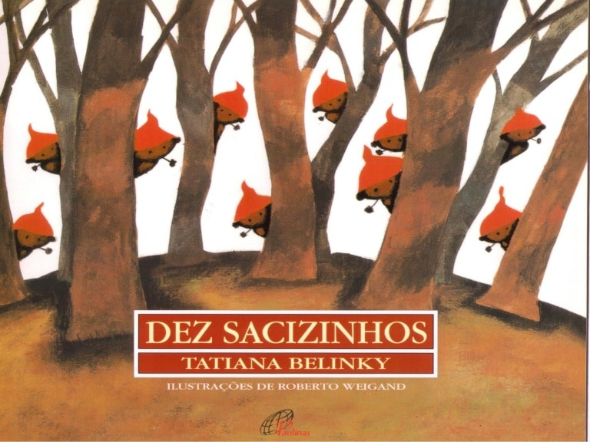

DESENHE OS DEZ SACIZINHOS:

**NOME:______________________________________________________________**

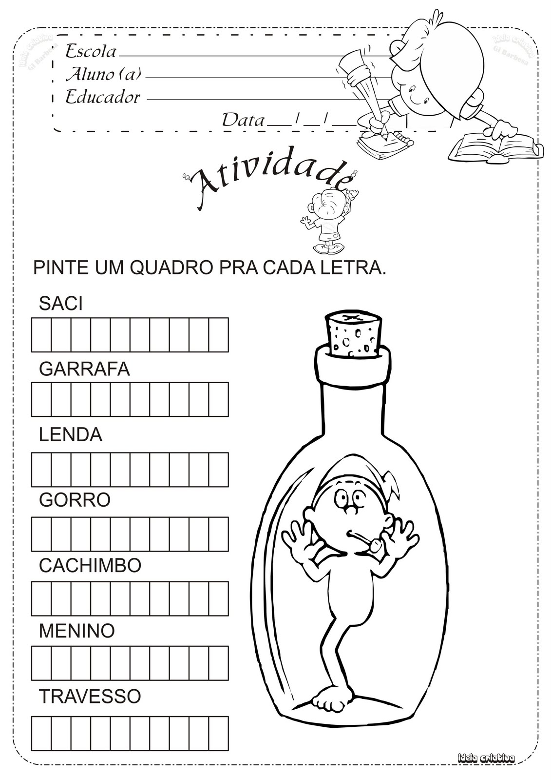

NOME:_______________________________________________________________

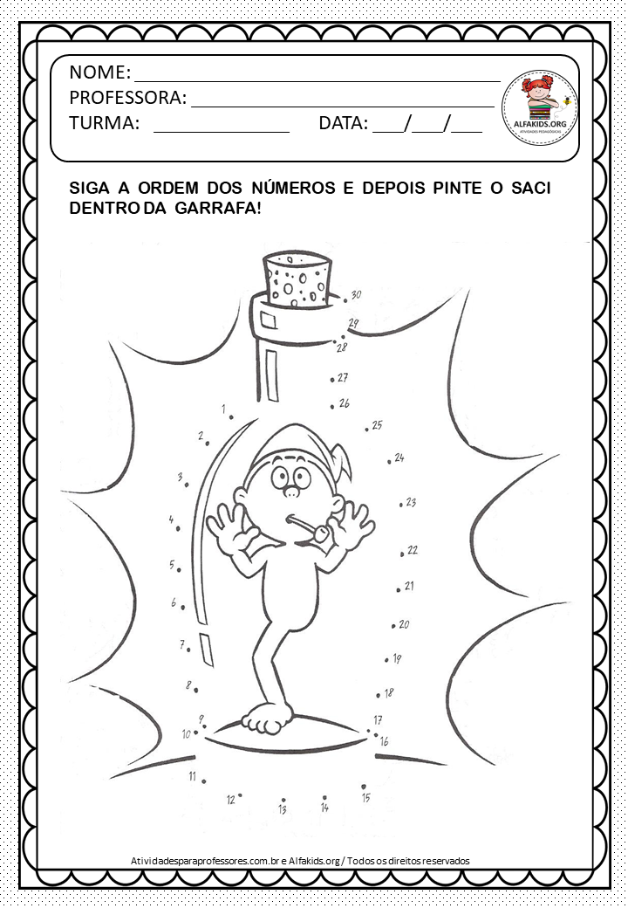

NOME:______________________________________________________________

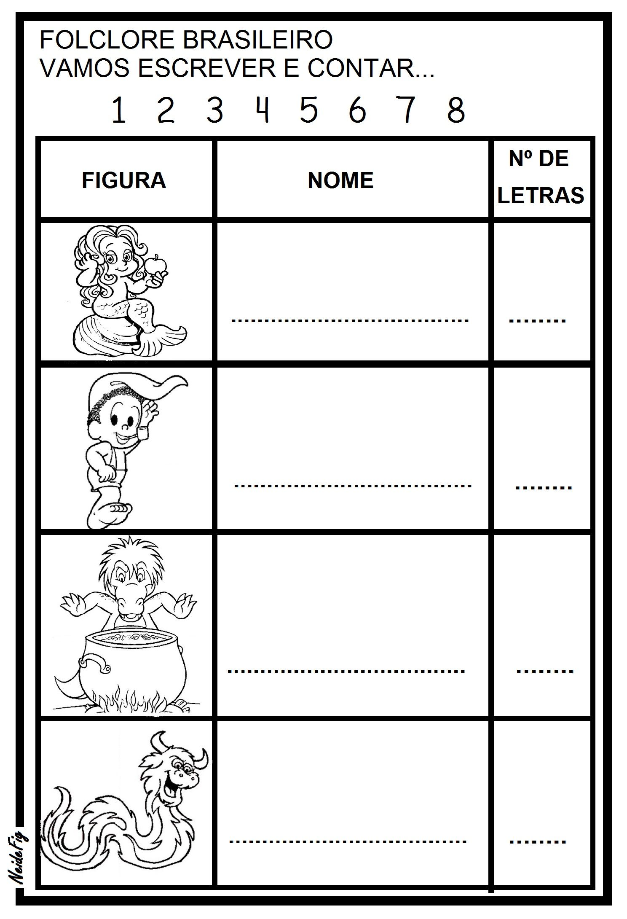

NOME:_______________________________________________________________

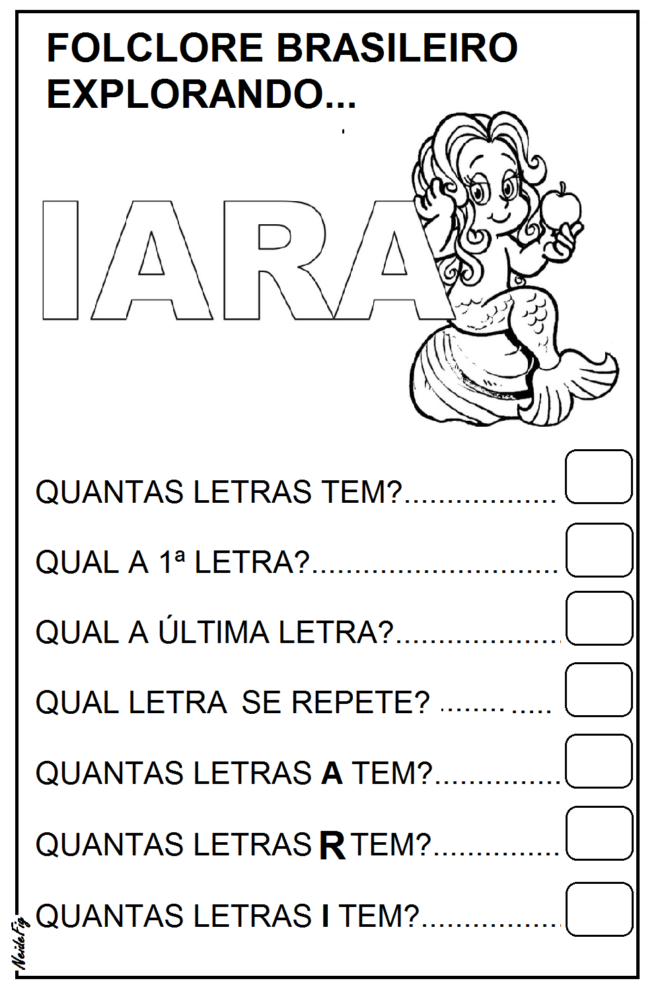

NOME:_____________________________________________________________

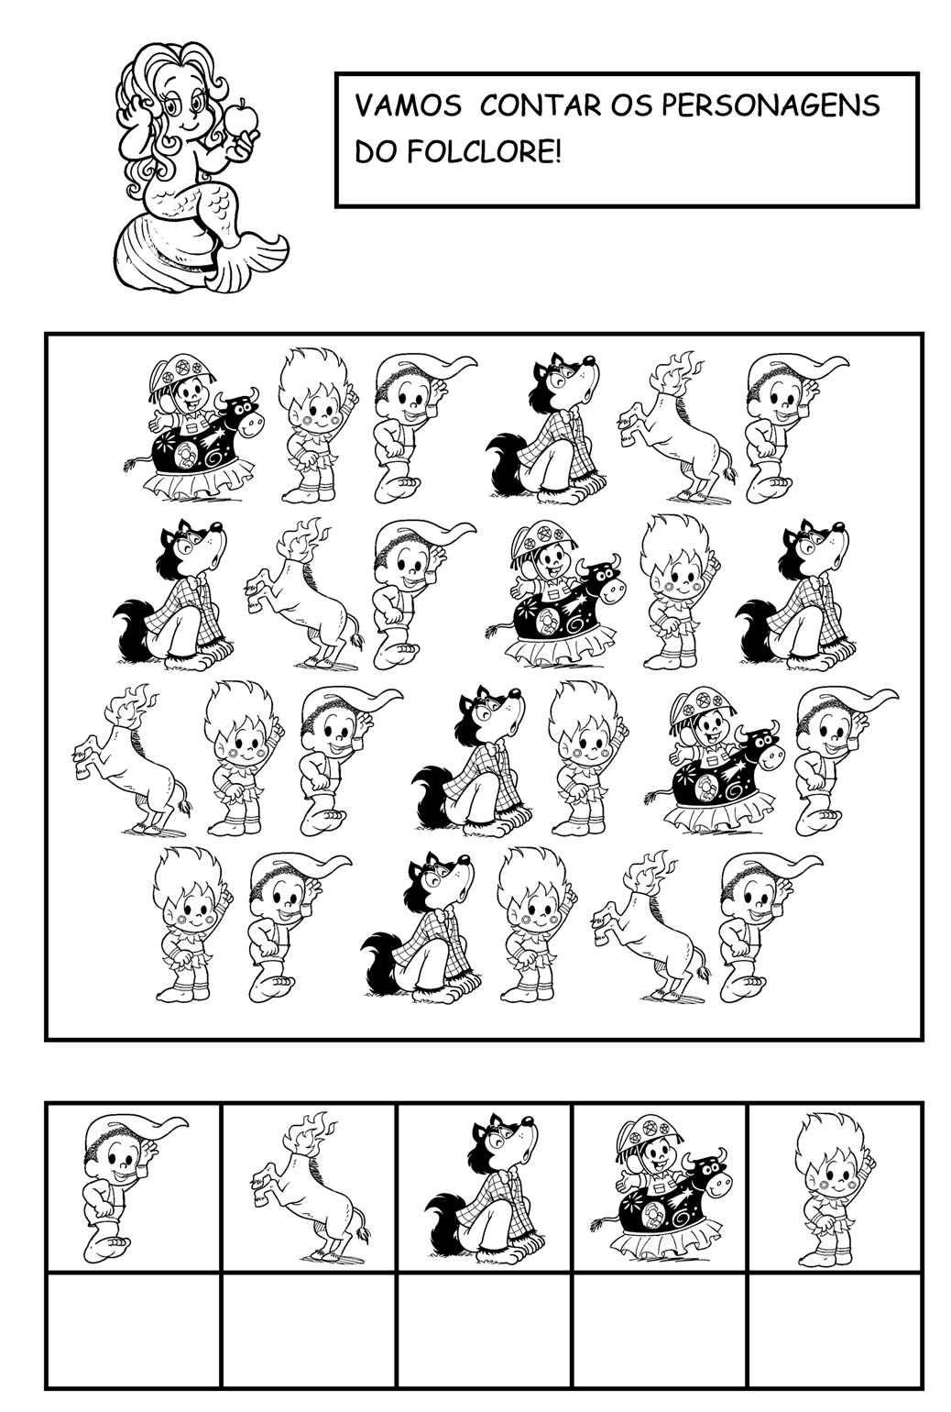

NOME:____________________________________________________________

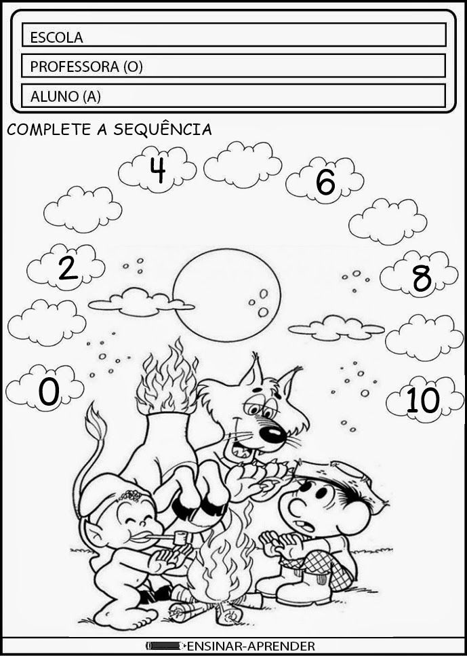

NOME:_______________________________________________________________

AS CANTIGAS TAMBÉM FAZEM PARTE DE NOSSO FOLCLORE:

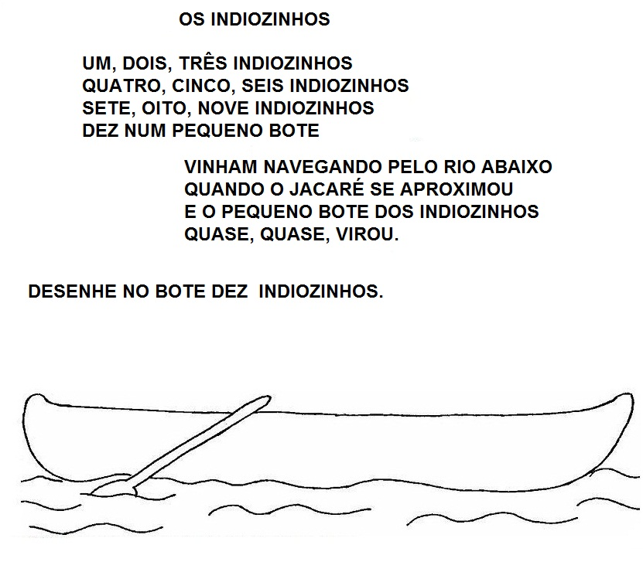

NOME:____________________________________________________________

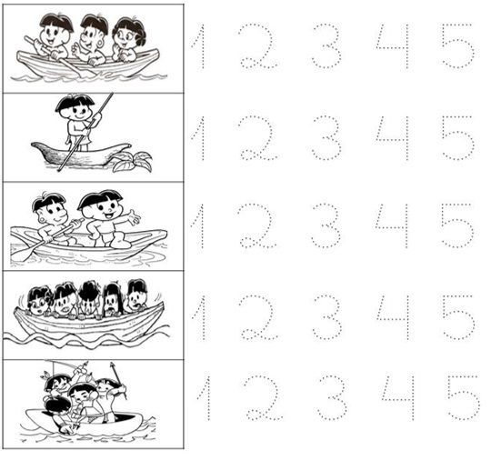

NOME:____________________________________________________________

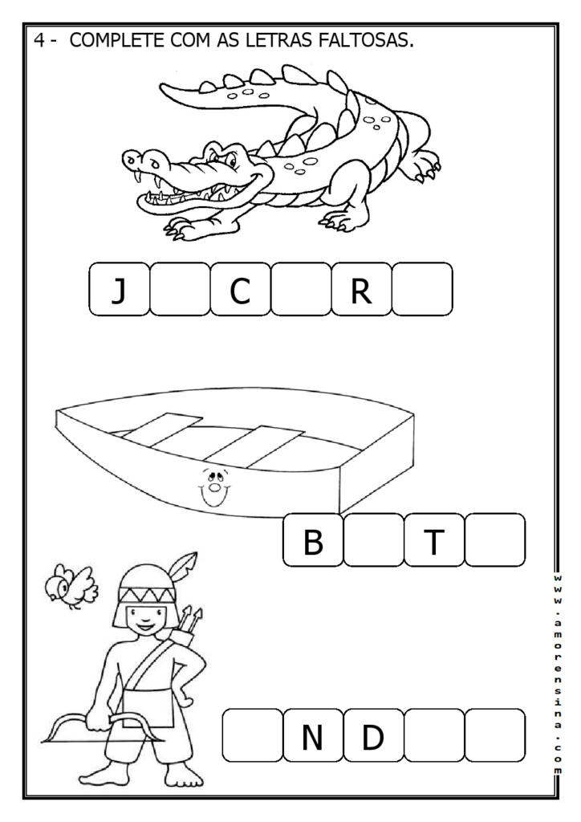

NOME:____________________________________________________________

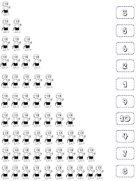

NOME:_____________________________________________________________

**PINTE, RECORTE E MONTE O COCAR DO INDIOZINHO E SE DIVIRTA.**

