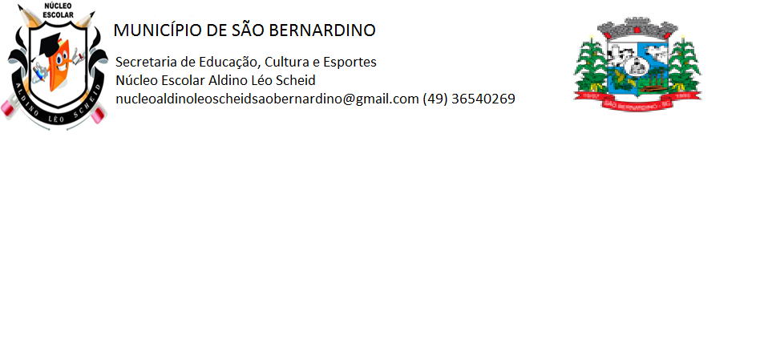**NÚCLEO ESCOLAR ALDINO LÉO SCHEID**

**QUINZENA DE 02/08 A 13/08/2021**

**DIA: _____/____/2021 ANO: 5º ANO ( ) MAT ( )VESP**

**ATIVIDADE DE LÍNGUA INGLESA**

**PROFESSORA JOSIANE HEINEN WENTZ**

**ALUNO (A): ___________________________________________________________________**

DAILY ROUTINES (Rotinas diárias)

Estas são algumas das expressões mais utilizadas em rotinas.

1. Observe as imagens e leia as expressões abaixo:

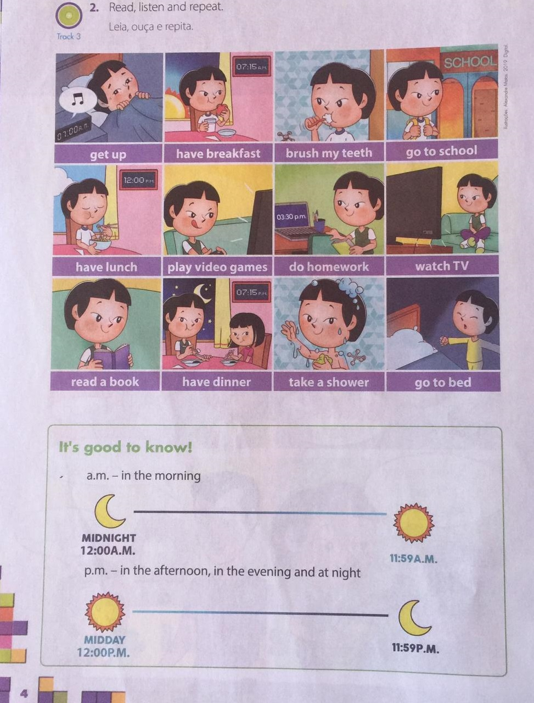

1. Observe as imagens e escreva o que elas representam, conforme as imagens e frases da página anterior:

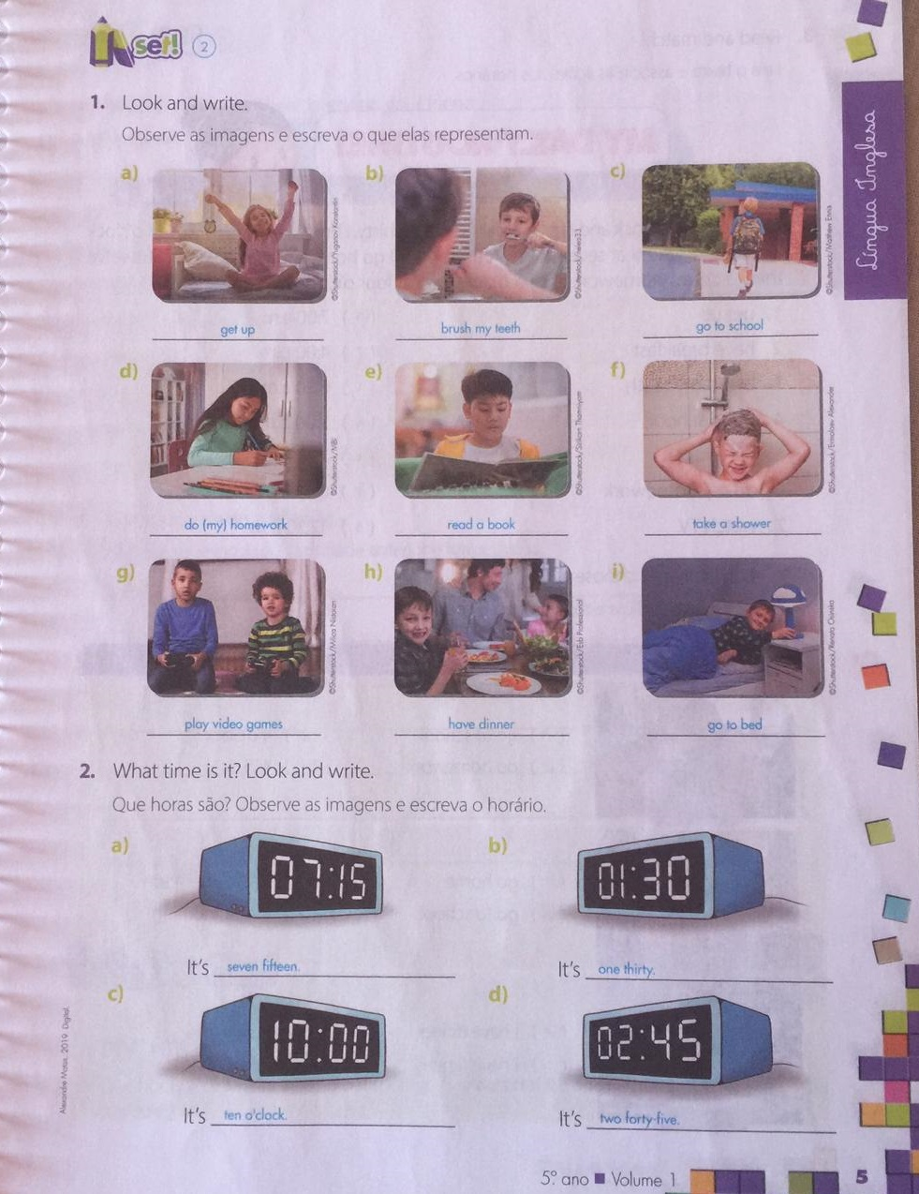

1. Observando as imagens e as frases, escreva a tradução das frases abaixo:

**Exemplo:** Get up: Levantar

Have breakfast: ___________________________________________________

Brush my teeth: ___________________________________________________

Go to school: _____________________________________________________

Have lunch: ______________________________________________________

Play video games: _________________________________________________

Do homework: ____________________________________________________

Watch TV: ________________________________________________________

Read a book: _____________________________________________________

Have dinner: ______________________________________________________

Take a shower: ____________________________________________________

Go to bed: ________________________________________________________

1. Copie as frases acima (inglês e português) em seu caderno.