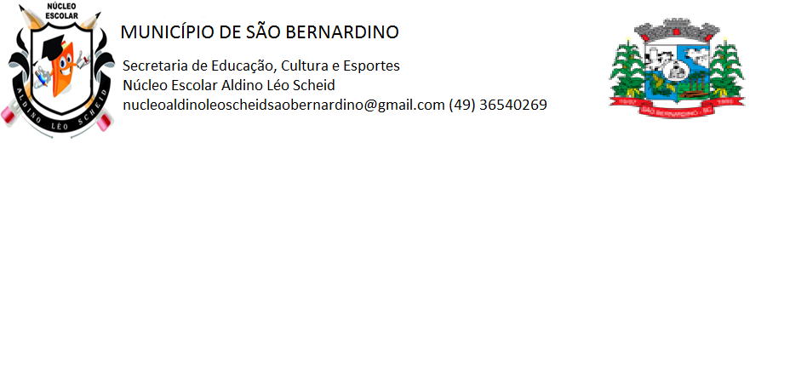**NÚCLEO ESCOLAR ALDINO LÉO SCHEID**

**QUINZENA DE 14/06 A 25/06/2021**

**DIA: _____/____/2021 ANO: 1º ANO ( ) MAT ( )VESP**

**ATIVIDADE DE LÍNGUA INGLESA**

**PROFESSORA JOSIANE HEINEN WENTZ**

**ALUNO (A): ___________________________________________________________________**

**CONTINUANDO NOSSO ESTUDOS SOBRE AS CORES, FAÇA AS ATIVIDADES ABAIXO.**

**PINTE COM AS CORES INDICADAS:**

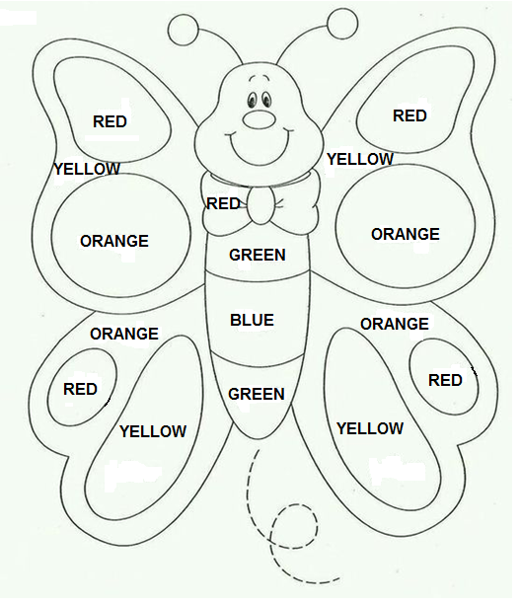

**ESCREVA AS CORES EM INGLÊS E DEPOIS ENCONTRE-AS NO CAÇA PALAVRAS:**

VERMELHO: ________________________________________________________________

AZUL: _____________________________________________________________________

AMARELO: _________________________________________________________________

LARANJA: __________________________________________________________________

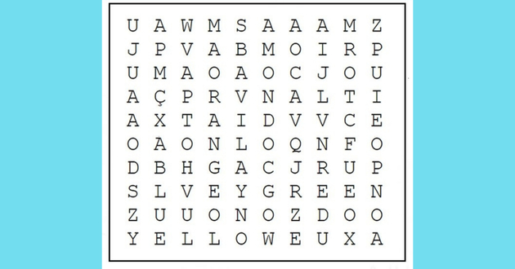VERDE: ____________________________________________________________________

PINTE OS NÚMEROS COM AS CORES INDICADAS:

1. – RED 2 – YELLOW 3 – BLUE 4 – GREEN

5 – ORANGE 6 – PURPLE 7 – BROWN 8 – BLACK

