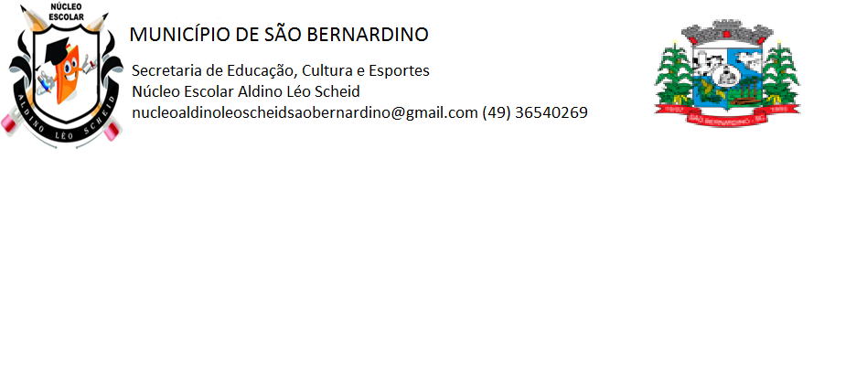**NÚCLEO ESCOLAR ALDINO LÉO SCHEID**

**QUINZENA DE 19/04 A 30/04/2021**

**DIA: _____/____/2021 ANO: 4º ANO ( ) MAT ( )VESP**

**ATIVIDADE DE LÍNGUA INGLESA**

**PROFESSORA JOSIANE HEINEN WENTZ**

**ALUNO (A): ___________________________________________________________________**

**HELLO STUDENTS!**

**VAMOS RELEMBRAR UM POUCO O QUE ESTUDAMOS ATÉ AQUI!**

1. COMPLETE O DIÁLOGO ABAIXO:

**TEACHER:** GOOD MORNING, CLASS!

**CLASS:** __________________________________________________________!

**TEACHER:** MY NAME IS JOSIANE. I AM YOUR ENGLISH TEACHER. WHAT IS YOUR NAME?

**CARLOS:** _________________________________________________________.

**TEACHER:** HOW ARE YOU, CARLOS?

**CARLOS:** _________________________________________________________.

**TEACHER:** AND YOU, WHAT IS YOUR NAME?

**MARINA:** __________________________________________________________.

**TEACHER:** HELLO GIRL. WHAT IS YOUR NAME?

**GIRL:** MY NAME IS MARINA.

**TEACHER:** ________________________________________________________.

**MARINA:** I AM GOOD, TEACHER!

1. QUE EXPRESSÃO A PROFESSORA USA PARA CUMPRIMENTAR OS ALUNOS?

_________________________________________________________________________

1. EM QUE PERÍODO DO DIA A AULA ESTÁ ACONTECENDO?

_________________________________________________________________________

1. COM QUE FRASE A PROFESSORA DIZ O SEU NOME?

_________________________________________________________________________

1. COM QUE FRASE JOSIANE DIZ A DISCIPLINA QUE VAI LECIONAR?

_________________________________________________________________________

1. QUAL FRASE A PROFESSORA USA PARA PERGUNTAR O NOME DOS ALUNOS?

________________________________________________________________________

1. ASSINALE A ALTERNATIVA CORRETA:
2. ATÉ MEIO DIA, DIZEMOS:

( ) GOOD AFTERNOON ( ) GOOD NIGHT ( ) GOOD MORNING

1. Á TARDE, DIZEMOS:

( ) GOOD AFTERNOON ( ) GOOD NIGHT ( ) GOOD MORNING

1. NA DESPEDIDA, PODEMOS DIZER:

( ) HI ( ) HELLO ( ) GOOD BYE

1. QUANDO NOS DESPEDIMOS À NOITE, DIZEMOS:

( ) GOOD EVENING ( ) GOOD NIGHT ( ) GOOD MORNING

1. SAUDAÇÃO COMUM ENTRE AMIGOS:

( ) HALLO ( ) HELLO ( ) HI

1. COMPLETE AS RESPOSTAS:

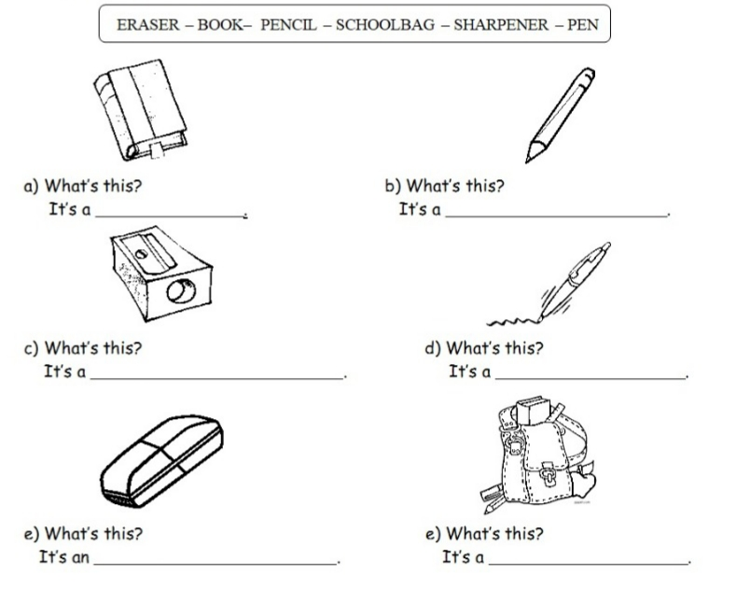

1. ESCREVA AS FRASES EM INGLÊS:
2. A MOCHILA É VERDE. ____________________________________________________________
3. O APONTADOR É VERMELHO. _____________________________________________________
4. A CANETA É AZUL. ______________________________________________________________
5. O CADERNO É BRANCO. _________________________________________________________
6. A BORRACHA É ROSA. ___________________________________________________________
7. ESCREVA AS FRASES EM PORTUGUÊS:
8. THE CHAIR IS YELLOW. __________________________________________________________
9. THE PENCIL IS BLACK. ___________________________________________________________
10. THE BOOK IS ORANGE. __________________________________________________________
11. THE TABLE IS BROWN. ___________________________________________________________
12. THE RULER IS WHITE. ____________________________________________________________