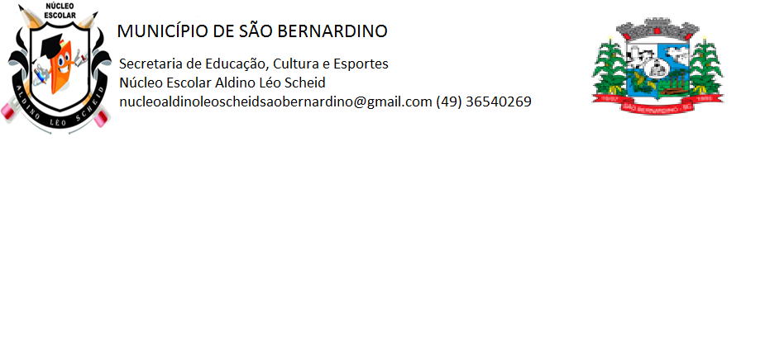**NÚCLEO ESCOLAR ALDINO LÉO SCHEID**

**QUINZENA DE 05/04 A 16/04/2021**

**DIA: _____/____/2021 ANO: 5º ANO ( ) MAT ( )VESP**

**ATIVIDADE DE LÍNGUA INGLESA**

**PROFESSORA JOSIANE HEINEN WENTZ**

**ALUNO (A): ___________________________________________________________________**

**HELLO STUDENTS!**

**NESTA QUINZENA VAMOS ESTUDAR SOBRE OS MATERIAS ESCOLARES: SCHOOL SUPPLIES.**

**COPIE EM SEU CADERNO A LISTA COM O NOME DOS MATERIAS ESCOLARES:**

**SCHOOL SUPPLIES: MATERIAIS ESCOLARES**

BOOK: LIVRO

NOTEBOOK: CADERNO

PAPER: PAPEL

PEN: CANETA

PENCIL: LÁPIS

COLORED PENCIL: LÁPIS DE COR

ERASER: BORRACHA

RULER: RÉGUA

SCISSOR: TESOURA

GLUE: COLA

SHARPENER: APONTADOR

CASE: ESTOJO

SCHOOL BAG: MOCHILA

CHAIR: CADEIRA

DESK: CARTEIRA

TABLE: MESA

TEACHER: PROFESSOR(A)

STUDENT: ALUNO

CLASSROOM: SALA DE AULA

BOARD: QUADRO

TRANSLATE: (TRADUZA AS FRASES)

1. THE BOOK IS GRAY. _____________________________________________________________
2. THE ERASER IS ORANGE. ________________________________________________________
3. THE COPYBOOK IS PURPLE. ______________________________________________________
4. THE RULER IS GREEN. ___________________________________________________________
5. THE GLUE IS WHITE. _____________________________________________________________
6. THE SCHOOL BAG IS BLACK. ______________________________________________________
7. THE SCISSOR IS RED. ____________________________________________________________
8. THE PENCIL IS BLUE. ____________________________________________________________
9. THE SHARPENER IS YELLOW. _____________________________________________________
10. THE CASE IS PINK. ______________________________________________________________
11. A MESA É BRANCA. ______________________________________________________________
12. A CARTEIRA É MARROM. _________________________________________________________
13. A CADEIRA É AZUL. ______________________________________________________________
14. O CADERNO É VERDE. ___________________________________________________________
15. A CANETA É VERMELHA. _________________________________________________________

**IS: É OU ESTÁ THE: O, A, OS, AS**

ESCREVA O NOME DOS OBJETOS EM INGLÊS, DEPOIS PINTE.

