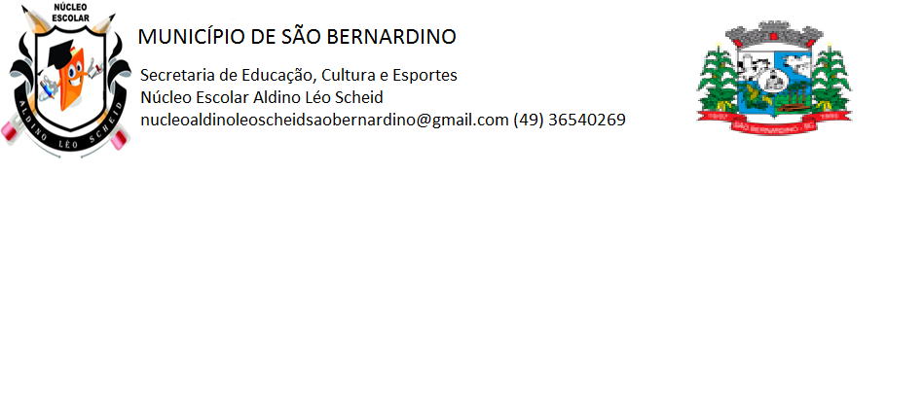**NÚCLEO ESCOLAR ALDINO LÉO SCHEID**

**QUINZENA DE 08/03 A 19/03/2021**

**DIA: _____/____/2021 ANO: 2º ANO ( ) MAT ( )VESP**

**ATIVIDADE DE LÍNGUA INGLESA**

**PROFESSORA JOSIANE HEINEN WENTZ**

**ALUNO (A): ___________________________________________________________________**

HELLO STUDENTS!

NESSA ATIVIDADE DESTA QUINZENA, VAMOS APRENDER AS CORES EM INGLÊS.

1. COPIE EM SEU CADERNO E PINTE AS BOLINHAS DA COR CORRESPONDENTE:

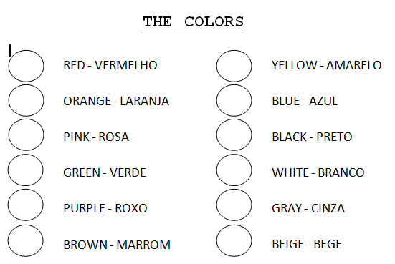

1. PINTE AS LETRAS COM A COR QUE ELAS REPRESENTAM:

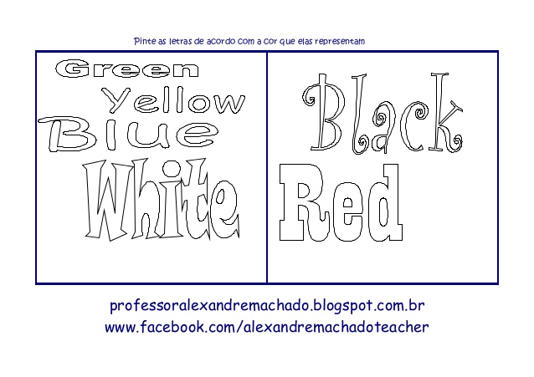

1. PINTE O DESENHO ABAIXO E AS CORES INDICADAS NOS BALÕES:

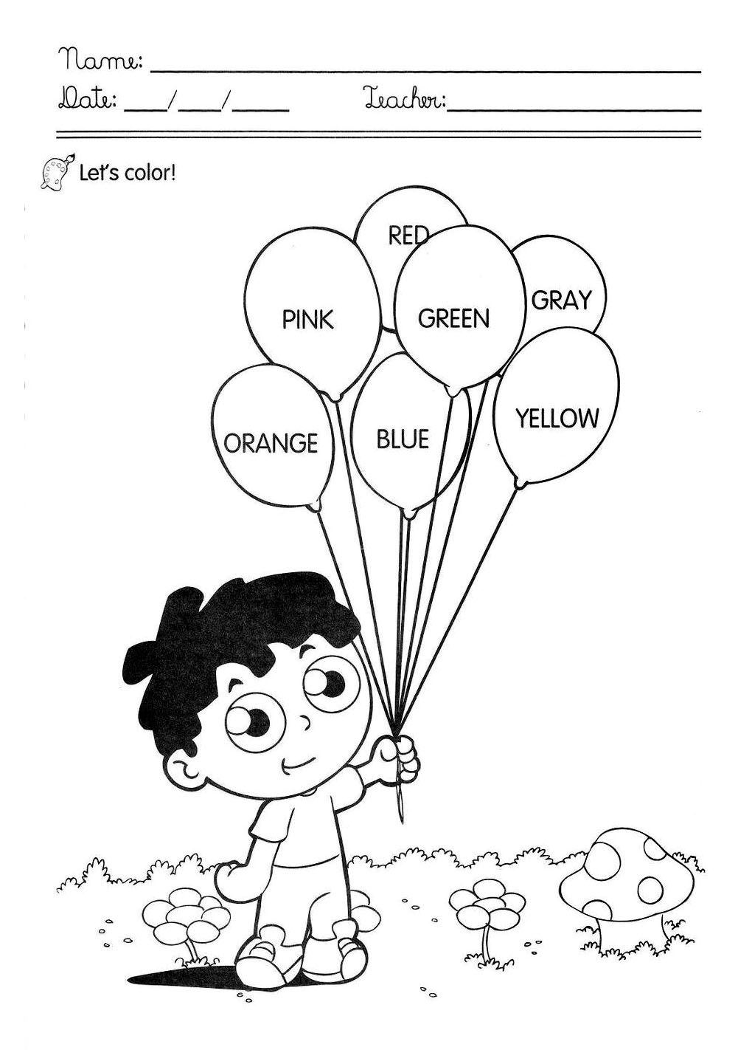

1. DAS CORES DESCRITAS NA ATIVIDADE ANTERIOR, ESCREVA EM PORTUGUÊS:
2. PINK: _________________________________________________________________
3. RED: _________________________________________________________________
4. ORANGE: _____________________________________________________________
5. YELLOW: _____________________________________________________________
6. GREEN: ______________________________________________________________
7. BLUE: ________________________________________________________________
8. GRAY: ________________________________________________________________