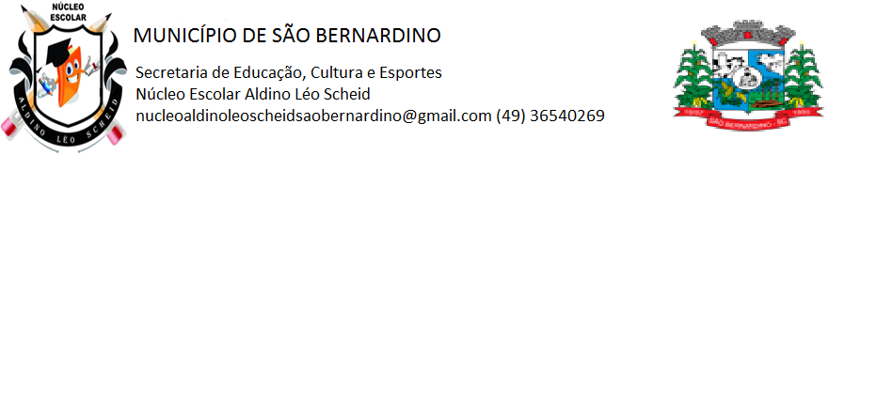

**ATIVIDADES REMOTA**

***PROFESSORA:_SILMARA W. MOTTER***

***ALUNO(a)___________________________________________________________________________________***

***ENDEREÇO___________________________________________________________________________________***

***ANO: 1º ANO***

***DATA :__________________________________________________________________________________________***

